University of Information Technology & Sciences

Department of

Computer Science and Engineering



**Project Report**

Course Title: Compiler Lab

Course Code: CSE-352

Submitted To

Md. Tasnin Tanvir

Lecturer, Department of CSE

Submitted By

Name : Md. Tamim Iqbal

Id : 0432220005101023

Batch : 52

Section : 6A1

**Problem Description:**

This lab project demonstrates the use of C++ functions to perform a wide range of basic arithmetic, logical, bitwise, and comparison operations. The project is modularly designed with a clear separation between the main program logic (code.cpp) and the function implementations (function.h). It acts as a mini calculator and logic simulator for integer and Boolean operations using hardcoded test values.

**Introduction:**

In computer programming, mastering arithmetic and logical operations is crucial, especially in low-level or system-level development such as embedded systems or compiler design. This project aims to reinforce those foundational concepts by implementing a set of functions in C++ that perform mathematical operations (addition, subtraction, multiplication, division, modulus), logical operations (AND, OR, NOT, XOR), comparison checks (equal, greater, smaller), and bit-level operations (bitwise AND, OR, XOR, NOT, shifts). It is developed using standard C++ with an emphasis on simplicity and clarity, ideal for beginners learning the fundamentals of computation and logic.

**Methodology:**

The project follows a modular approach and includes the following components:

* Header File (function.h):

Contains the definitions of all the operations as separate reusable functions, including:

Arithmetic functions: jog_hobe, biyog_hobe, gun_hobe, vag_hobe, vagshesh_hobe

Comparison functions: soman_check, boro_check, choto_check, bigORequal, smallORequal

Utility functions: abs_man, max_eta, min_eta, Sqr, cube

Logical functions: AND, OR, NOT, XOR

Bitwise functions: bitwiseAND, bitwiseOR, bitwiseXOR, bitwiseNOT, leftSHIFT, rightSHIFT

Increment/Decrement: ek_beshi, ek_kom

Parity check: jor_check, bijor_check

* Main File (code.cpp):

This file contains the main() function, where fixed values (a = 10, b = 3, x = true, y = false) are used to call and test each of the functions in a sequential manner. The outputs of each function call are printed to the console to validate correctness.

* Tools Used:

Language: C++

Libraries: Standard C++ library (<bits/stdc++.h>)

Compilation & Execution: Any standard C++ compiler (e.g., GCC, g++)

**Result:**

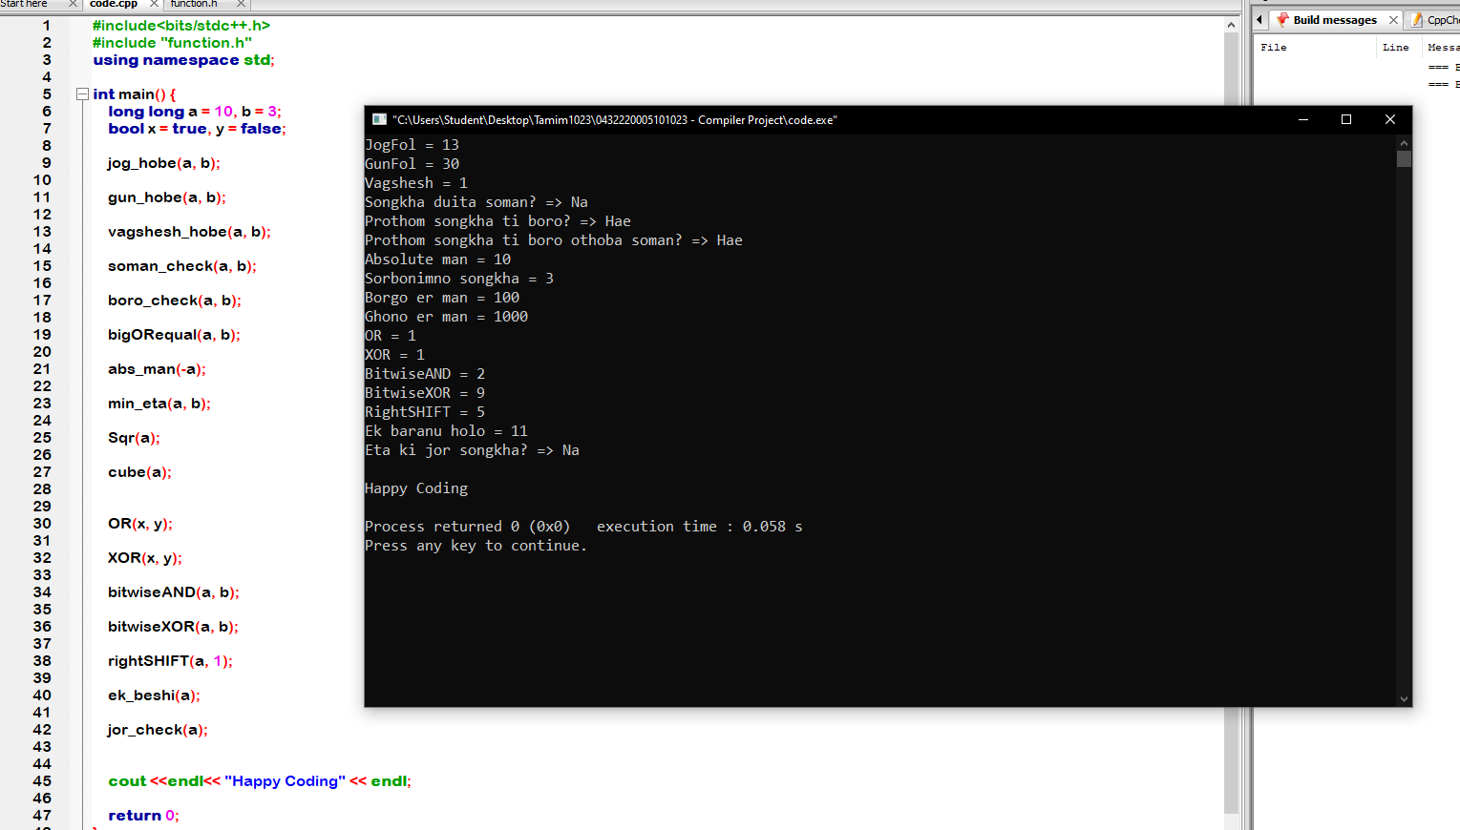

**Conclusion:**

This project successfully demonstrates how basic computational and logical operations can be modularized and reused in C++. It highlights the importance of function decomposition and promotes clean code structure by isolating logic into a header file. While the project uses simple fixed inputs, the structure can easily be extended to support dynamic user input or integration into larger systems. It provides a solid foundation for learning not only arithmetic but also low-level logical and bit manipulation essential for understanding computer architecture and microcontroller programming.